**Shift Reduce parser** attempts for the construction of parse in a similar manner as done in bottom-up parsing i.e. the parse tree is constructed from leaves(bottom) to the root(up). A more general form of the shift-reduce parser is the LR parser.

This parser requires some data structures i.e.

* An input buffer for storing the input string.
* A stack for storing and accessing the production rules.

**Basic Operations –**

* **Shift:** This involves moving symbols from the input buffer onto the stack.
* **Reduce:** If the handle appears on top of the stack then, its reduction by using appropriate production rule is done i.e. RHS of a production rule is popped out of a stack and LHS of a production rule is pushed onto the stack.
* **Accept:** If only the start symbol is present in the stack and the input buffer is empty then, the parsing action is called accept. When accepted action is obtained, it is means successful parsing is done.
* **Error:** This is the situation in which the parser can neither perform shift action nor reduce action and not even accept action.

**Example 1 –** Consider the grammar   
        S –> S + S   
        S –> S * S   
        S –> id

Perform Shift Reduce parsing for input string “id + id + id”.

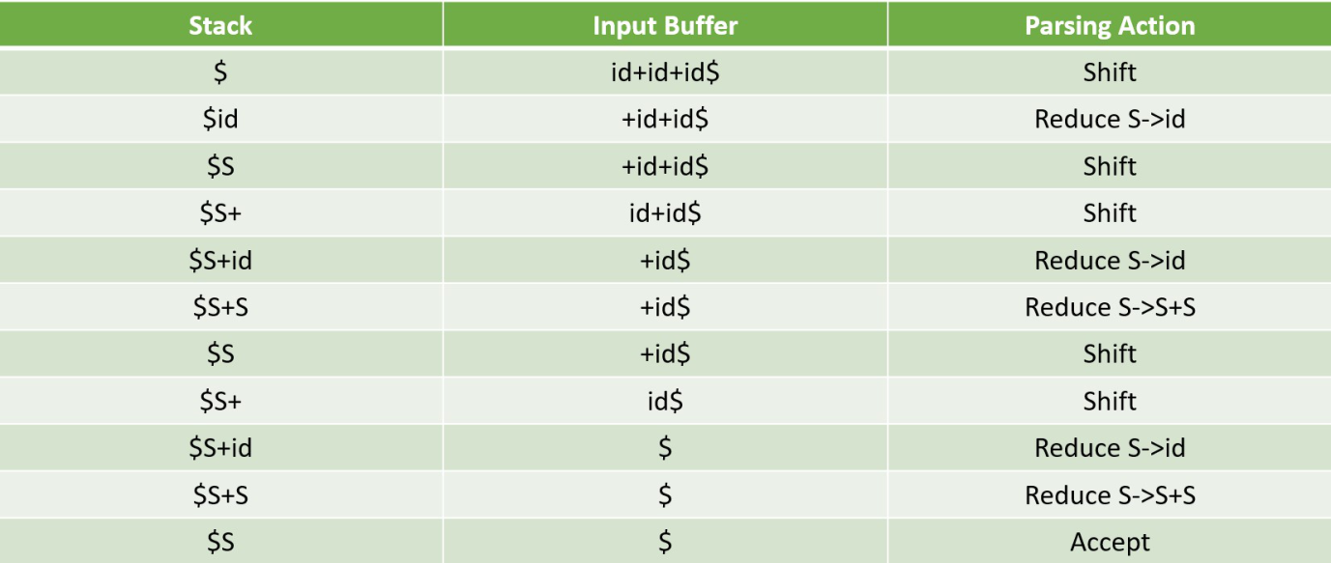

//Including Libraries

#include<stdio.h>

#include<stdlib.h>

#include<string.h>

//Global Variables

int z = 0, i = 0, j = 0, c = 0;

// Modify array size to increase

// length of string to be parsed

char a[16], ac[20], stk[15], act[10];

// This Function will check whether

// the stack contain a production rule

// which is to be Reduce.

// Rules can be E->2E2 , E->3E3 , E->4

void check()

{

    // Copying string to be printed as action

    strcpy(ac,"REDUCE TO E -> ");

    // c=length of input string

    for(z = 0; z < c; z++)

    {

        //checking for producing rule E->4

        if(stk[z] == '4')

        {

            printf("%s4", ac);

            stk[z] = 'E';

            stk[z + 1] = '\0';

            //printing action

            printf("\n$%s\t%s$\t", stk, a);

        }

    }

    for(z = 0; z < c - 2; z++)

    {

        //checking for another production

        if(stk[z] == '2' && stk[z + 1] == 'E' &&

                                stk[z + 2] == '2')

        {

            printf("%s2E2", ac);

            stk[z] = 'E';

            stk[z + 1] = '\0';

            stk[z + 2] = '\0';

            printf("\n$%s\t%s$\t", stk, a);

            i = i - 2;

        }

    }

    for(z=0; z<c-2; z++)

    {

        //checking for E->3E3

        if(stk[z] == '3' && stk[z + 1] == 'E' &&

                                stk[z + 2] == '3')

        {

            printf("%s3E3", ac);

            stk[z]='E';

            stk[z + 1]='\0';

            stk[z + 1]='\0';

            printf("\n$%s\t%s$\t", stk, a);

            i = i - 2;

        }

    }

    return ; //return to main

}

//Driver Function

int main()

{

    printf("GRAMMAR is -\nE->2E2 \nE->3E3 \nE->4\n");

    // a is input string

    strcpy(a,"32423");

    // strlen(a) will return the length of a to c

    c=strlen(a);

    // "SHIFT" is copied to act to be printed

    strcpy(act,"SHIFT");

    // This will print Labels (column name)

    printf("\nstack \t input \t action");

    // This will print the initial

    // values of stack and input

    printf("\n$\t%s$\t", a);

    // This will Run upto length of input string

    for(i = 0; j < c; i++, j++)

    {

        // Printing action

        printf("%s", act);

        // Pushing into stack

        stk[i] = a[j];

        stk[i + 1] = '\0';

        // Moving the pointer

        a[j]=' ';

        // Printing action

        printf("\n$%s\t%s$\t", stk, a);

        // Call check function ..which will

        // check the stack whether its contain

        // any production or not

        check();

    }

    // Rechecking last time if contain

    // any valid production then it will

    // replace otherwise invalid

    check();

    // if top of the stack is E(starting symbol)

    // then it will accept the input

    if(stk[0] == 'E' && stk[1] == '\0')

        printf("Accept\n");

    else //else reject

        printf("Reject\n");

}

// This code is contributed by Ritesh Aggarwal

Output

GRAMMAR is -

E->2E2

E->3E3

E->4

stack input action

$ 32423$ SHIFT

$3 2423$ SHIFT

$32 423$ SHIFT

$324 23$ REDUCE TO E -> 4

$32E 23$ SHIFT

$32E2 3$ REDUCE TO E -> 2E2

$3E 3$ SHIFT

$3E3 $ REDUCE TO E -> 3E3

$E $ Accept